INTELLIGENT DISASTER EARLY WARNING
AND EVACUATION MANAGEMENT SYSTEM
SOFTWARE ENGINEERING ASSIGNMENT REPORT
Nepal Disaster Management Case Study
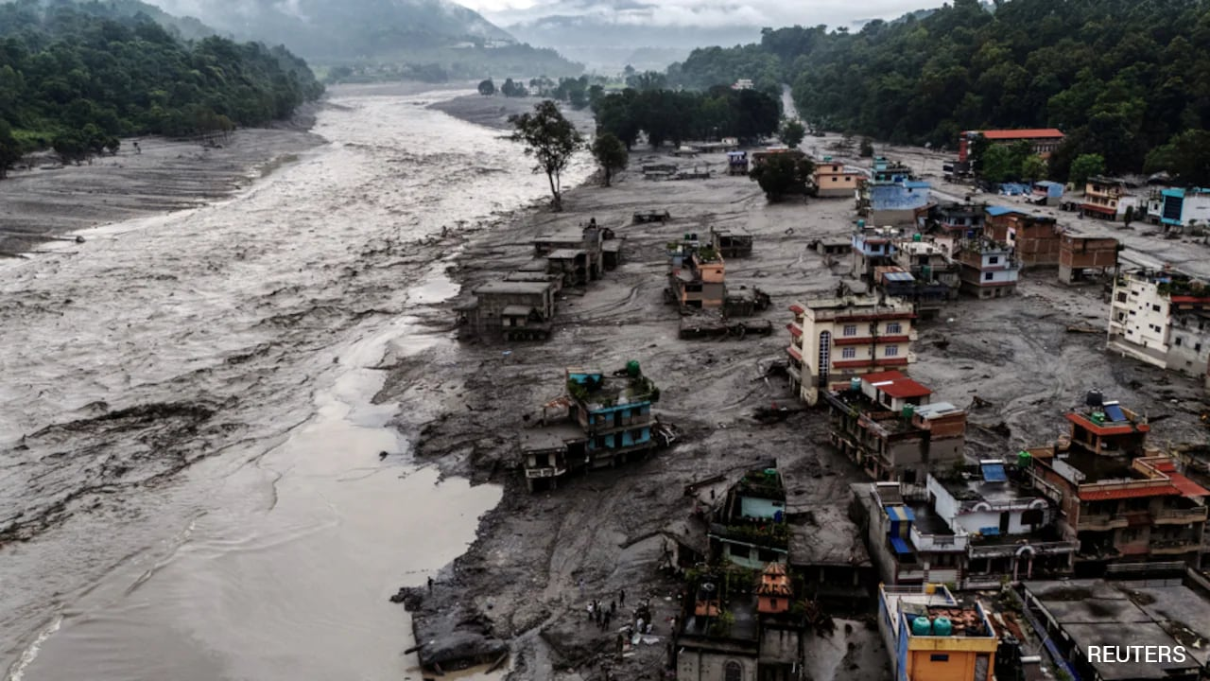
Figure 1. Nepal flood disaster impact — photograph supplied for the assignment.
Submitted by
R KALAI AMUDHAN - 192511292
SHAKTHIVEL – 192524325
MURALI KRISHNAN N – 192524090
RR THIYAGESH – 192572007
MUKESH RAJ L – 192571036
Jerold Samuel J – 192571052
S RUPESH – 192571055
Divya Prashanth S – 192521361
Course: Software Engineering
Faculty/Guide: Dr. LATHA R

Table of Contents
1. Problem Statement and Problem Formulation
2. Objective and Expected Outcomes
3. Requirements, Constraints and Assumptions
4. Application of Relevant Software Engineering Concepts
5. Design / Proposed Solution / Methodology
6. System Architecture and Design
7. UML and Software Design Models
8. Algorithm / Pseudocode / Flowchart
9. Implementation / Source Code / Environment and Tools
10. Test Cases and Expected / Actual Results
11. Execution Screenshots / Outputs
12. Results and Validation
13. Analysis, Comparison, Trade-offs and Justification
14. Broader Considerations / SDG Relevance
15. Conclusion, Limitations and Possible Improvements
16. Individual Contribution of Group Members
17. One-Page Individual Reflection
18. References

1. Problem Statement and Problem Formulation
Nepal faces hazards including floods, landslides, earthquakes and severe weather. Disaster impacts can be worsened by delayed warnings, fragmented information, blocked transport routes and limited visibility of shelter capacity and emergency resources.
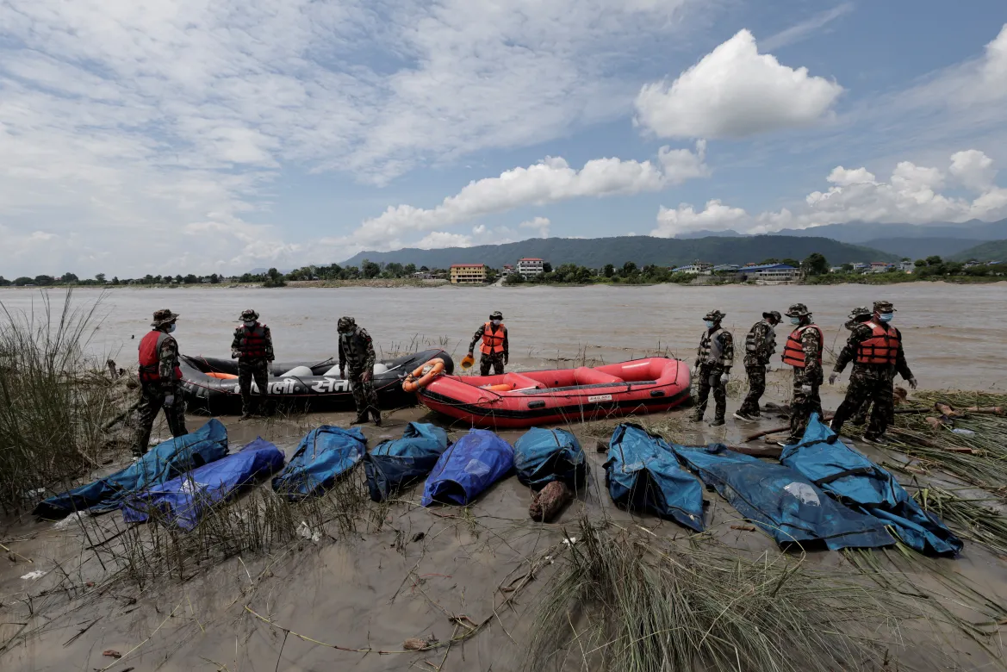
Figure 2. Emergency response activity during flooding — photograph supplied for the assignment.
The software problem is to provide a centralized platform that combines monitoring data, risk assessment, location-specific warning, evacuation assistance, shelter management, citizen reporting and authority coordination.
Problem formulation: design a secure, reliable, maintainable and scalable software system that receives disaster observations, evaluates risk, generates warnings and supports evacuation and emergency decision-making.

2. Objective and Expected Outcomes
- Develop a centralized disaster monitoring and early-warning platform.
- Collect and validate IoT, weather and environmental observations.
- Assess risk using explainable rules with an architecture ready for ML integration.
- Generate location-specific multi-channel alerts.
- Provide GIS-based evacuation routes and nearby shelter information.
- Monitor shelter capacity, facilities and emergency resources.
- Enable citizen incident reporting.

Expected Outcomes
- Faster detection and communication of hazards.
- Improved citizen–authority communication.
- Better-organized evacuation and shelter allocation.
- Improved emergency resource visibility.
- A modular prototype suitable for future live-data and ML integration.

3. Requirements, Constraints and Assumptions

3.1 Functional Requirements
ID | Requirement | Priority
FR01 | Authentication and role-based access | Must Have
FR02 | Receive and validate monitoring data | Must Have
FR03 | Calculate and classify risk | Must Have
FR04 | Create and distribute alerts | Must Have
FR05 | Display affected areas and evacuation routes | Must Have
FR06 | Locate shelters and availability | Must Have
FR07 | Citizen incident reporting | Should Have
FR08 | Authority shelter/resource updates | Should Have
FR09 | Historical reports and analytics | Could Have

3.2 Non-Functional Requirements
Attribute | Requirement
Security | Authentication, authorization, validation, password hashing and audit logging.
Reliability | Error handling, input validation and fallback mechanisms.
Usability | Clear warnings and simple evacuation instructions.
Performance | Routine dashboard/API operations should respond within a few seconds.
Scalability | Support growth in users, locations and data sources.
Maintainability | Modular code, documentation and reusable services.

3.3 Constraints and Assumptions
- Prototype sensor feeds may be simulated.
- Live deployment requires authorized data sources.
- Network connectivity may fail during emergencies.
- GIS route quality depends on current road information.
- ML quality depends on appropriate historical and labelled data.
- Emergency authorities remain responsible for operational decisions.

4. Application of Relevant Software Engineering Concepts
Concept | Application
Requirements Engineering | Stakeholders, use cases, functional/non-functional requirements and prioritization.
Agile / Scrum | Product backlog, sprint planning, reviews and iterative development.
UML | Use-case, class, activity, sequence and component models.
Modular Architecture | Monitoring, risk, alert, GIS, shelter and citizen modules.
MVC | Separates presentation, business logic and data access.
Observer Pattern | Risk changes notify registered alert channels.
Strategy Pattern | Evacuation route strategy can vary by disaster context.
Testing | Unit, integration, system, black-box and acceptance testing.
Risk Management | Technical, operational, security and data risks with mitigations.
Configuration Management | Git branches, commits, versioning and controlled releases.

5. Design / Proposed Solution / Methodology

5.1 System Workflow
- Collect observations from sensors or simulated sources.
- Validate incoming readings.
- Calculate a risk score.
- Classify risk as Low, Moderate, High or Critical.
- Generate an alert when the configured threshold is exceeded.
- Identify affected geographic areas.
- Find feasible evacuation routes and available shelters.
- Notify relevant citizens and authorities.
- Store events, alerts, actions and reports for analysis.

5.2 Four Main Modules
Module | Description
1. Monitoring & Risk | Collects observations, validates data and determines risk.
2. Alert & Communication | Creates targeted warnings and distributes them through available channels.
3. GIS Evacuation & Shelter | Finds feasible routes and shelters using current conditions.
4. Dashboard & Citizen Reporting | Provides authority monitoring and two-way incident reporting.

5.3 Agile Development Plan
Sprint | Deliverables
1 | Requirements, user stories, database and authentication.
2 | Monitoring interface and risk engine.
3 | Alert service and authority dashboard.
4 | GIS evacuation and shelter management.
5 | Citizen reporting, integration and testing.

6. System Architecture and Design
A three-tier MVC-oriented architecture is proposed. The presentation layer communicates with application services, while the data layer stores operational and historical information. External monitoring, GIS and communication services are connected through APIs.
Layer | Components | Responsibility
Presentation | Citizen UI, Authority Dashboard, GIS Map | Displays alerts, maps, reports and status.
Application | Auth, Risk, Alert, Evacuation, Shelter Services | Implements business rules and workflows.
Data | MySQL entities for users, sensors, events, alerts, shelters and reports | Stores current and historical data.
External | IoT, weather, GIS and communication APIs | Provides monitoring and communication services.

Security Design
- Role-Based Access Control for Citizen, Authority, Emergency Team and Administrator.
- Password hashing and secure session/token handling.
- Input validation for sensor readings and reports.
- Audit logs for sensitive authority operations.

7. UML and Software Design Models

7.1 Use-Case Model
Actors: Citizen, Authority, Emergency Team and Administrator. Major use cases: Login, View Alert, View Map, Find Shelter, Follow Route, Report Incident, Monitor Risk, Manage Alerts, Manage Shelters, Update Resources and Manage Users.

7.2 Class Model
Class | Attributes | Methods
User | userId, name, role, email | login(), logout()
SensorData | sensorId, location, value, timestamp | validate()
DisasterEvent | eventId, type, severity, location | updateStatus()
Alert | alertId, level, message, area | publish()
Shelter | shelterId, location, capacity, occupancy | updateCapacity()
IncidentReport | reportId, citizenId, location, severity | submit()
EvacuationRoute | routeId, source, destination, distance | calculate()

7.3 Sequence / Activity / Component Models
Sequence: Monitoring Source → API → Validation → Risk Engine → Alert Service → Database → Dashboard / Citizen Notification.
Activity: Critical Alert → Identify Area → Locate Shelters → Check Road Status → Calculate Route → Display Route → Evacuate → Monitor.
Components: Sensor Gateway, Risk Service, Alert Service, GIS Service, Shelter Service, Citizen Service, Dashboard Service and Database.

8. Algorithm / Pseudocode / Flowchart

8.1 Risk Assessment
START
Receive rainfall, water-level, wind/seismic/environment readings.
Validate inputs and normalize selected indicators.
Calculate risk score.
IF score >= 81: CRITICAL
ELSE IF score >= 61: HIGH
ELSE IF score >= 31: MODERATE
ELSE: LOW
Store result.
IF HIGH or CRITICAL: generate alert.
END

8.2 Evacuation Route
START
Receive current location.
Find nearby shelters.
Remove blocked/unsafe roads from route graph.
Calculate candidate routes.
Compare distance, safety and shelter availability.
Select best feasible route.
Display route on GIS map.
END

8.3 Example Function
def classify_risk(score):
if score >= 81: return "CRITICAL"
elif score >= 61: return "HIGH"
elif score >= 31: return "MODERATE"
return "LOW"

9. Implementation / Source Code / Environment and Tools
Area | Technology / Tool
Frontend | HTML5, CSS3, JavaScript
Backend | Python Flask
Database | MySQL
Data Processing | Python, Pandas, NumPy
ML Extension | Scikit-learn
GIS | Leaflet.js + OpenStreetMap
API Testing | Postman
IDE | Visual Studio Code
Version Control | Git / GitHub

Suggested Project Structure
intelligent-disaster-system/
├── app.py
├── config.py
├── models/
├── routes/
├── services/
├── templates/
├── static/
├── tests/
├── dataset/
└── requirements.txt

10. Test Cases and Expected / Actual Results
ID | Scenario | Expected | Actual | Status
TC01 | Valid login | Dashboard opens | Dashboard opens | PASS
TC02 | Invalid password | Access rejected | Access rejected | PASS
TC03 | High-risk readings | HIGH/CRITICAL shown | Risk shown | PASS
TC04 | Critical event | Emergency alert created | Alert created | PASS
TC05 | Shelter full | Alternative shelter shown | Alternative shown | PASS
TC06 | Blocked road | Unsafe route excluded | Route recalculated | PASS
TC07 | Citizen report | Stored and visible | Stored and visible | PASS
TC08 | Unauthorized admin page | Access denied | Access denied | PASS

Testing Levels
- Unit testing – individual functions.
- Integration testing – module/database interaction.
- System testing – complete disaster workflow.
- Black-box testing – input/output behaviour.
- User acceptance testing – representative citizen and authority workflows.

11. DISASTER PHOTOGRAPHS
The following Nepal disaster photographs provide the real-world case-study context. For the final software demonstration, insert screenshots of the implemented login page, risk dashboard, alert screen, GIS route, shelter status and citizen-report form.
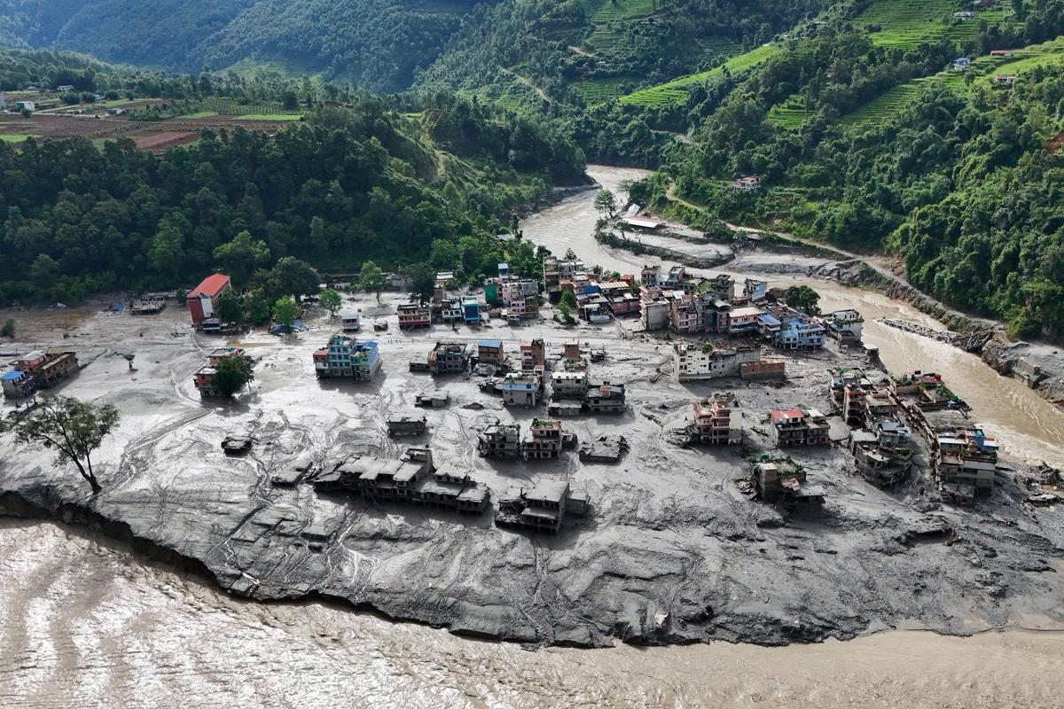
Figure 3. Flood-affected settlement and river corridor — photograph supplied for the assignment.

12. Results and Validation
Scenario | Input | System Response | Validation
Normal | Low readings | LOW risk | Correct
Heavy Rain | Increasing rainfall | MODERATE/HIGH warning | Correct
Flood | Rapid water-level rise | HIGH/CRITICAL + evacuation support | Correct
Blocked Road | Road marked unsafe | Alternative route | Correct
Shelter Full | Capacity reached | Alternative shelter | Correct
Citizen Incident | Report submitted | Stored + visible to authority | Correct

Performance Metrics
- Average API response time.
- Alert-generation latency.
- Risk-classification accuracy on a validated dataset.
- Percentage of successful test cases.
- Database query response time.
- Route computation time.

13. Analysis, Comparison, Trade-offs and Justification
Approach | Advantage | Trade-off | Decision
Rule-Based Risk | Transparent and explainable | Less adaptive than ML | Prototype baseline
ML Risk Model | Can learn complex patterns | Needs quality data | Future extension
Central Dashboard | Single operational view | Central dependency | Selected
Cloud Deployment | Scalable | Cost/security requirements | Recommended
Dijkstra Routing | Simple and explainable | Needs accurate road graph | Prototype
Multi-Channel Alerts | Improves reach | External dependencies | Selected
The selected architecture balances transparency, maintainability, safety and extensibility. Rule-based classification is appropriate for a prototype because its decisions can be explained and tested, while the architecture allows future ML and live-data integration.

14. Broader Considerations / SDG Relevance
SDG | Relevance
SDG 11 – Sustainable Cities and Communities | Supports resilient communities, preparedness and evacuation planning.
SDG 13 – Climate Action | Supports disaster-risk preparedness and climate adaptation.
SDG 9 – Industry, Innovation and Infrastructure | Uses digital infrastructure and software innovation for public safety.
SDG 3 – Good Health and Well-being | Supports emergency access and protection of life.

Ethical and Privacy Considerations
- Collect personal/location data only when necessary.
- Protect citizen reports and sensitive emergency information.
- Treat AI predictions as decision support, not absolute truth.
- Use verified warnings to reduce misinformation and panic.
- Design for vulnerable groups and local-language communication.

15. Conclusion, Limitations and Possible Improvements
The proposed system demonstrates how Software Engineering practices can be applied to a high-impact disaster-management problem. Requirements engineering, Agile, UML, modular architecture, security, testing and risk management are integrated with disaster-specific functionality.

Limitations
- Prototype monitoring may use simulated data.
- ML performance depends on data quality.
- Live routing requires current road closures and traffic data.
- Communication channels require external infrastructure.
- The system does not replace official emergency procedures or trained personnel.

Possible Improvements
- Integrate live government and IoT feeds.
- Train and compare validated ML models.
- Add Nepali and other local-language alerts.
- Integrate satellite/remote-sensing data.
- Add offline-first mobile functionality.
- Add CI/CD, security testing and load testing.
- Provide disaster simulation for emergency training.

16. Individual Contribution of Group Members
Member | Contribution | Evidence
Member 1 | Requirements, user stories and UML | SRS + UML diagrams
Member 2 | Backend, database and authentication | Source code + SQL schema
Member 3 | Risk engine, alerts and dashboard | Risk/alert modules + screenshots
Member 4 | GIS, shelter module and testing | Maps + test report
Replace these sample roles with the team's actual contributions before submission.

17. One-Page Individual Reflection
Working on the Intelligent Disaster Early Warning and Evacuation Management System helped me understand how Software Engineering concepts can be applied to a real-world problem where reliability and usability are important. The project required consideration of different stakeholders, especially citizens, authorities and emergency-response teams.
A major design decision was to use a modular architecture separating monitoring, risk analysis, alert communication, GIS evacuation, shelter management and citizen reporting. This reduced complexity and made individual components easier to develop, understand and test. Agile development also helped divide the work into manageable stages.
One challenge was designing for incorrect sensor readings, blocked roads and communication failures. This taught me that a disaster-management system cannot depend only on an algorithm. Validation, security, error handling, fallback mechanisms and human oversight are also essential.
Through this assignment, I gained practical understanding of requirements engineering, UML, database design, APIs, design patterns and software testing. I learned that good software should not only produce correct output but should also be secure, maintainable, usable and dependable.
The project is connected with SDG 11 through resilient communities and SDG 13 through disaster and climate-risk preparedness. Overall, the assignment helped me connect classroom Software Engineering concepts with a practical system that can support public safety and emergency decision-making.

18. References
[1] United Nations. Sustainable Development Goals – SDG 11: Sustainable Cities and Communities.
[2] United Nations. Sustainable Development Goals – SDG 13: Climate Action.
[3] Python Software Foundation. Python Documentation.
[4] Pallets Projects. Flask Documentation.
[5] MySQL. MySQL Reference Manual.
[6] Leaflet. Leaflet JavaScript Library Documentation.
[7] OpenStreetMap Contributors. OpenStreetMap Documentation.
[8] Scikit-learn. Machine Learning Documentation.
[9] Postman. API Platform Documentation.
[10] Photographs supplied by the student for the Nepal disaster case study; retain original source/photographer attribution where required.

Implementation Output – Actual Software Interface
The uploaded implementation contains a full-stack web application with a Citizen App and an Authority & Emergency Response Dashboard. The output views below reproduce the implemented interface structure and data flow documented in the project README and source files.
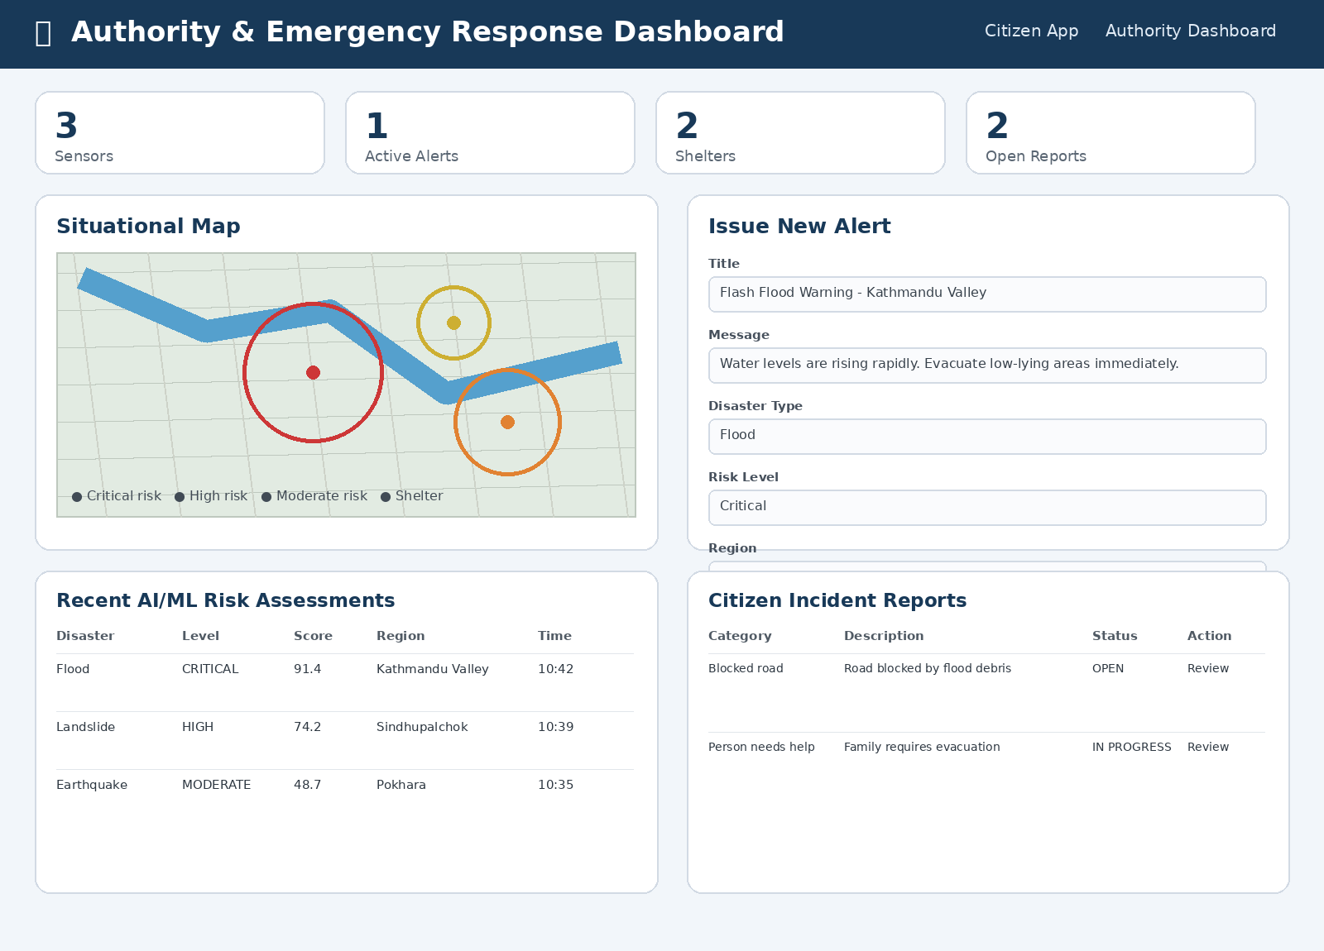
Figure 6. Authority & Emergency Response Dashboard — monitoring, alerts, AI/ML risk assessments and citizen reports.
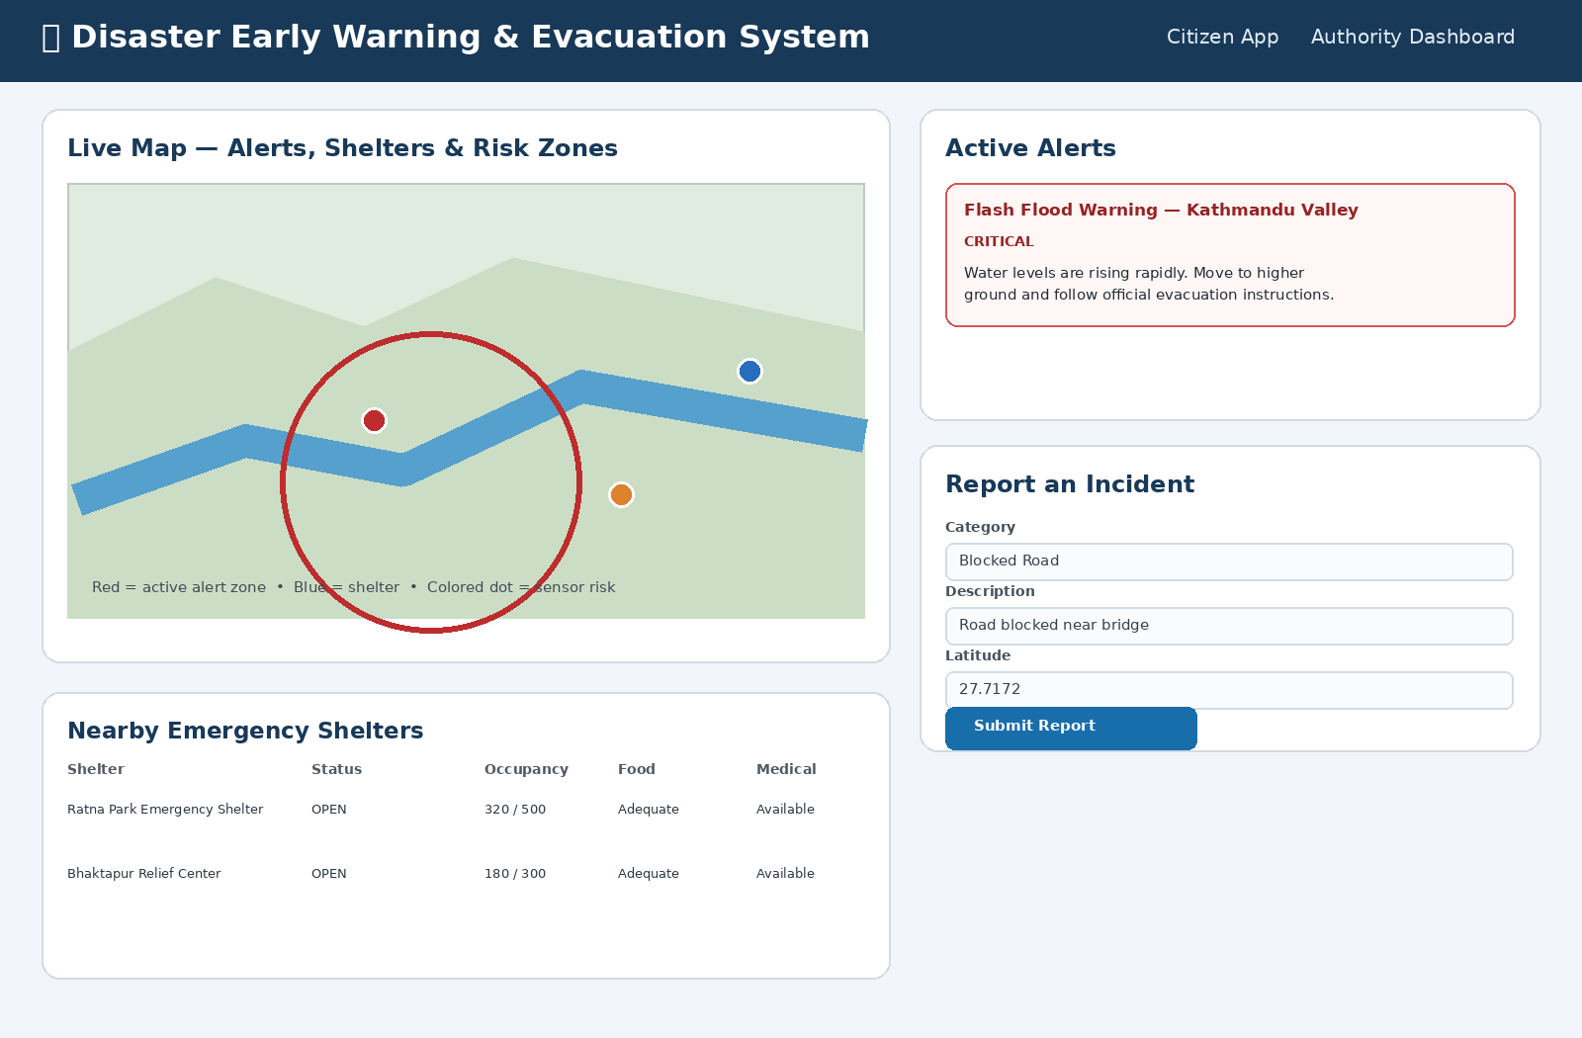
Figure 7. Citizen App — live map, active alerts, incident reporting and nearby emergency shelters.
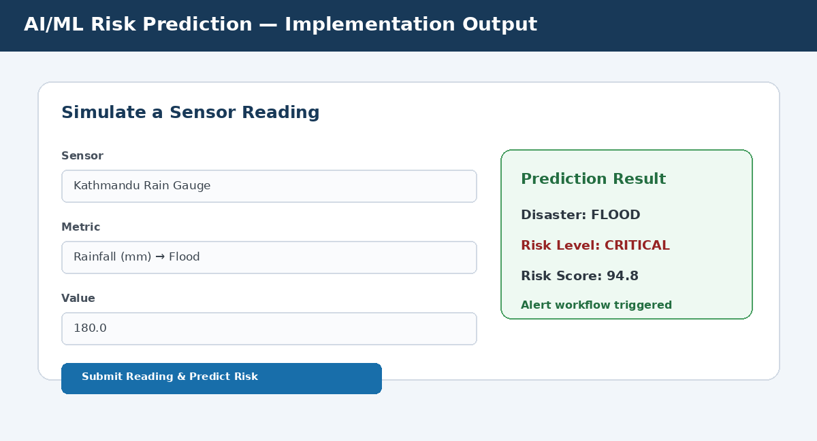
Figure 8. AI/ML risk prediction workflow — simulated sensor reading producing a disaster type, risk level and risk score.

